|  |
| --- |
| **A**  **PROJECT REPORT**  **on**    **AI DRIVEN AGRIBOT**    SUBMITTED TO AN AUTONOMOUS INSTITUTE, AFFILIATED TO  SAVITRIBAI PHULE PUNE UNIVERSITY, PUNE IN THE PARTIAL  FULFILLMENT OF THE REQUIREMENTS FOR THE AWARD OF THE DEGREE  **BACHELOR OF TECHNOLOGY**  **in**  **(Electronics & Telecommunication Engineering)**    **SUBMITTED BY**    VAIBHAV NRUPNARAYAN Reg. No :2021AETN1101136  HARISH BAGUL Reg. No :2021AETN1111122  ABHIMAN BADE Reg. No :2021AETN1101076        Under the Guidance of  **DR. KAVITA JOSHI**      **DEPARTMENT OF ELECTRONICS & TELECOMMUNICATION**  **ENGINEERING**  **G H RAISONI COLLEGE OF ENGINEERING AND MANAGEMENT**  **WAGHOLI, PUNE 412207**  **AY: 2024-25**  **(Winter)** |



# **CERTIFICATE**

This is to certify that the project report entitled

**“AI DRIVEN AGRIBOT”**

Submitted by

**VAIBHAV NRUPNARAYAN Reg. No :2021AETN1101136**

**HARISH BAGUL Reg. No :2021AETN1111122**

**ABHIMAN BADE Reg. No :2021AETN1101076**

are a Bonafide students of this institute and the work has been carried out by them under the supervision of (**DR. KAVITA JOSHI**) and it is approved for the partial fulfilment of the requirement of an Autonomous Institute, Affiliated to Savitribai Phule Pune University, for the award of the degree of **Bachelor of Technology in Electronics & Telecommunication Engineering** in the academic year 2024-25.

(**DR. KAVITA JOSHI**) (**Dr. S. K. Waghmare**) Guide H.O.D.

(……………………….) (**Dr. R. D. Kharadkar**)

**External Examiner** Director

GHRCEM, Pune

**Date**:

**Place**: Pune



# DECLARATION BY THE STUDENT(S)

We declare that the project entitled **"AI DRIVEN AGRIBOT”** submitted by us for the award of degree Bachelor of Technology in Electronics & Telecommunication Engineering is the record of work carried out by during the period from July, 2023 to December 2023 under the guidance of **DR. Kavita Joshi** and has not formed the basis for the award of any degree, diploma, associate ship, fellowship, titles in this or any other University or other institution of higher learning.

We further declare that the material obtained from other sources has been, duly acknowledged

in the thesis.

**VAIBHAV NRUPNARAYAN Reg. No :2021AETN1101136**

**HARISH BAGUL Reg. No :2021AETN1111122**

**ABHIMAN BADE Reg. No :2021AETN1101076**

Date: / /

Place: Pune

# ACKNOWLEDGMENT

It gives us great pleasure in presenting **AI DRIVEN AGRIBOT** as our B.Tech. project. Words have never seemed as inadequate as now when we are endeavouring to express our gratitude at the culmination of our B.Tech. Project to all those who have made it possible. Even the best efforts are waste, without the proper guidance and advice of our project guide **DR. KAVITA JOSHI** for the consistent guidance, co-operation, inspiration, practical approach, and constructive criticism, which provided us the much-needed impetus to work hard & also thanks **Dr. S. K. Waghmare** Head of E&TC Department for their continuous support & valuable suggestions.

We take this opportunity to thank our Campus Director **Dr. R. D. Kharadkar** for their whole hearted support, motivation & valuable suggestions.

We would also like to thank **Dr. S. D. Hanwate** our Project Coordinator for her valuable support in providing us with the required information.

At the end, we would like to give special thanks to all staff members from **E&TC Department** of G H Raisoni College of Engineering and Management, Pune & our colleagues for their kind support & timely suggestions.

**VAIBHAV NRUPNARAYAN Reg. No :2021AETN1101136**

**HARISH BAGUL Reg. No :2021AETN1111122**

**ABHIMAN BADE Reg. No :2021AETN1101076**

# **ABSTRACT**

**The AI-driven Agribot project presents an innovative solution to modernize rice farming by integrating Machine Learning (ML) and Internet of Things (IoT) technologies to automate rice planting, environmental monitoring, and crop management. Traditional rice cultivation is labour-intensive, time-consuming, and prone to inefficiencies, resulting in higher costs, inconsistent planting, and reduced yields. The Agribot is designed to address these challenges by precisely planting rice seedlings, monitoring plant growth, and evaluating crop health using advanced image processing techniques. By continuously collecting real-time data on soil moisture, temperature, and plant conditions through sensors, the system enables data-driven decision-making to optimize resource use, improve crop quality, and enhance yields.**

**AI-driven algorithms allow the Agribot to make intelligent decisions, such as detecting and responding to environmental changes, identifying plant diseases, and managing weeds, thereby improving overall farm management. The system reduces reliance on manual labor, increases planting accuracy, and enhances productivity, making farming more efficient and profitable. This project holds the potential to transform agricultural practices by fostering precision farming techniques, ultimately contributing to food security and sustainable agricultural development. By modernizing rice farming, the AI-driven Agribot can lead to significant advancements in crop production, benefiting both farmers and the agricultural industry.**

**Keywords: - (Crop disease detection, Rice crop plantation, Machine Learning, Hardware- Raspberry Pi, IR sensor, Ultrasonic Sensor)**

### TABLE OF CONTENTS

42

Page No.

CERTIFICATE 2

DECLARATION BY THE STUDENT(S) 3

ACKNOWLEDGMENT 4

ABSTRACT 5

TABLE OF CONTENT VI

VII

LIST OF FIGURES

LIST OF TABLES VIII

Sr. No. Title of Chapter Page No.

1. Introduction 10

1.1 Overview 11

* 1. Motivation 11
  2. Problem Definition and Objectives 12
  3. Project Scope & Limitations 13
  4. Methodologies of Problem solving 15

1. Literature Survey 17
2. System design
   1. Assumptions and Dependencies 19
   2. Functional Requirements 21
   3. External Interface Requirements (If Any)
      1. User Interfaces
      2. Hardware Interfaces
      3. Software Interfaces
      4. Communication Interfaces
3. System Design

4.1 System Architecture

* 1. Data Flow Diagrams
  2. Entity Relationship Diagrams

1. Project Plan

5.1 Project Estimate

* + 1. Reconciled Estimates
    2. Project Resources

5.2 Risk Management

* + 1. Risk Identification
    2. Risk Analysis

5.3 Project Schedule

5.3.1 Project Task Set

1. Project Implementation

6.1 Overview of Project Modules

1. Results
   1. Outcomes
   2. Screen Shots
2. Conclusions

8.1 Conclusions

8.2 Future Work

8.3 Applications

Bibliography

Appendix I

Datasheet/ software program

### LIST OF TABLES

TABLE No. ILLUSTRATION PAGE NO.

5.3 Literature Survey

Chapter-1

Introduction

INTRODUCTION

Agriculture is a cornerstone of many economies, especially in regions where rice serves as a staple crop. Traditional methods of rice cultivation, however, are labor-intensive, time-consuming, and often inefficient, leading to increased costs and inconsistent yields. In response to these challenges, the AI-Driven Agribot project aims to revolutionize rice farming by automating the planting process and enhancing the quality analysis of crops through advanced technologies.

The Agribot leverages Artificial Intelligence (AI) and Internet of Things (IoT) technologies to create a smart, automated system capable of precise rice planting and real-time environmental monitoring. Using image processing techniques, the Agribot can evaluate plant quality, detect weeds, and make informed decisions to optimize crop production. Additionally, sensors continuously monitor key environmental factors such as soil moisture and temperature, enabling farmers to manage their crops more effectively and efficiently.

By reducing reliance on manual labor, improving planting accuracy, and providing detailed data for decision-making, this project seeks to enhance agricultural productivity, reduce costs, and ensure sustainable farming practices. The AI-Driven Agribot represents a significant step towards modernizing agriculture, utilizing technology to increase food security and promote more efficient farming methods.

### 1.1 Overview

Overview for the project, which addresses key challenges such as labor shortages, inconsistent quality control, and risks posed to farmers by hazardous conditions like snake-infested fields. The primary goal of the Agribot is to automate rice planting while also improving crop quality through AI-powered analysis. The methodology involves the integration of hardware (e.g., Raspberry Pi, motors, cameras) and software (image processing and machine learning) to plant rice and monitor crop health. The project’s expected outcomes include improved crop yields, enhanced quality control, and cost reduction by minimizing labor expenses.

expands on this by highlighting the integration of Internet of Things (IoT) technology alongside AI. The Agribot is designed to not only plant rice but also monitor environmental conditions like soil moisture and temperature using IoT sensors. The system aims to improve planting precision, reduce manual labor, and increase productivity. A functional prototype will be developed, focusing on planting accuracy and crop health monitoring using machine learning algorithms.

In essence, the Agribot seeks to modernize agriculture by leveraging AI and IoT for more efficient and sustainable rice farming.

### 1.2 Motivation

The motivation behind the AI-driven Agribot project stems from the critical need to address several pressing challenges in rice farming. Traditional rice cultivation methods are labor-intensive, time-consuming, and often dangerous due to the presence of hazardous insects and snakes in the fields. This leads to labor shortages, high costs, and inconsistent planting, all of which negatively impact crop yields and quality. Moreover, ensuring high-quality rice production is difficult without effective monitoring and control mechanisms, which affects market value and consumer trust.

The AI-driven Agribot project is motivated by the pressing challenges in traditional rice farming: labor shortages, inconsistent quality control, and hazardous field conditions. By integrating advanced technologies such as artificial intelligence and the Internet of Things, the Agribot aims to automate rice planting, enhance crop quality, and optimize resource management. This innovative approach seeks to reduce dependence on manual labor, improve operational efficiency, and promote sustainable agricultural practices, thereby transforming the rice farming landscape

The project aims to overcome these challenges by developing an autonomous Agribot that automates rice planting and integrates AI and IoT technologies. The system seeks to reduce dependency on manual labor, enhance planting precision, and provide real-time monitoring of critical environmental factors such as soil moisture and temperature. By using AI-driven quality control and image processing, the Agribot will enable farmers to improve rice quality, optimize resource usage, and increase productivity, thereby modernizing the agricultural process and ensuring food security. This innovative approach aims to not only improve efficiency but also promote sustainability in rice farming, making it a timely and necessary solution to current agricultural challenges.

### 1.3 Problem Definition and Objectives

Rice farming, particularly in regions where it is a staple crop, is plagued by several persistent challenges that hinder productivity and efficiency. Traditional rice planting methods are highly labor-intensive and time-consuming, requiring significant human effort for tasks such as seed planting, crop monitoring, and disease control. The shortage of labor due to harsh working conditions in rice fields, such as waterlogged environments, exposure to dangerous animals like snakes, and long hours under difficult environmental conditions, further exacerbates these issues. This leads to higher labor costs and, in many cases, the inability to sustain timely and effective agricultural practices.

Additionally, traditional methods often result in inconsistent planting, which can lead to irregular crop spacing, suboptimal growth, and overall reduced yield. The lack of automated monitoring systems means that changes in environmental conditions—such as fluctuations in soil moisture, temperature, or the onset of crop diseases often go unnoticed until it is too late to take corrective measures. This can cause significant crop losses and negatively impact the quality and quantity of the rice produced.

Moreover, the absence of advanced quality control mechanisms makes it difficult for farmers to maintain uniform rice quality, affecting the marketability of their produce and reducing profitability. Farmers also struggle with timely disease detection and resource management, as they often rely on manual inspections and traditional farming knowledge, which are prone to human error.

In light of these challenges, the **AI-Driven Agribot** project seeks to offer an advanced, technology-driven solution to revolutionize rice farming. The Agribot will automate the rice planting process, allowing for precise planting and consistent crop spacing, which leads to optimized growth. It will also integrate AI and IoT technologies to provide continuous monitoring of environmental factors such as soil moisture, temperature, and crop health, enabling data-driven decision-making. By automating key processes and providing real-time insights, the Agribot will help farmers reduce labor dependency, cut costs, and improve the overall yield and quality of their crops, ensuring more sustainable and efficient rice production

Objectives:

1. **Automate Rice Planting**

* Develop a mechanism that can precisely plant rice seedlings, minimizing human intervention while ensuring optimal spacing and depth.

1. **Enhance Crop Quality Monitoring**

* Use AI-based image processing techniques to assess and maintain crop quality by detecting plant diseases and other irregularities early on.

1. **Optimize Resource Usage**

* Leverage IoT sensors to monitor environmental parameters like soil moisture and temperature, allowing data-driven decisions for fertilization and irrigation.

1. **Improve Agricultural Productivity**

* By automating repetitive and labor-intensive tasks, the Agribot aims to significantly boost rice production and minimize labor costs​

### 1.4 Project Scope & Limitations

The **AI-Driven Agribot** project aims to modernize rice farming by integrating advanced technologies into traditional agricultural practices. The expanded scope includes:

1. **Automation of Key Agricultural Tasks**

* In addition to rice planting, the Agribot can be extended to handle other essential tasks such as soil preparation, irrigation scheduling, and crop fertilization based on environmental data and crop needs. This holistic approach would further reduce manual intervention in the farming process.

1. **Scalability for Other Crops**

* While the primary focus is rice farming, the Agribot’s underlying AI and IoT framework could be adapted for other crops. By adjusting its planting mechanism and sensors, the system could be repurposed for a wide range of agricultural applications.

1. **Real-Time Data Analytics and Reporting**

* The system will provide real-time analytics and visual reports on crop conditions, environmental metrics, and operational performance. This will enable farmers to monitor multiple fields remotely and make informed decisions faster, improving farm management and resource allocation.

1. **Integration with Existing Agricultural Systems**

* The Agribot can be designed to integrate with other farm management systems, providing a seamless experience for farmers. It could be compatible with GPS systems for field navigation, weather prediction tools for proactive farm management, and other IoT devices used for agricultural monitoring.

1. **Sustainability and Eco-Friendly Farming**

* By using data-driven precision farming techniques, the Agribot minimizes the overuse of fertilizers and water, contributing to sustainable farming practices. It promotes resource efficiency, helping farmers reduce their environmental footprint while maximizing crop yield.

1. **Long-Term Monitoring and Machine Learning**

* Over time, the Agribot can accumulate large datasets about specific fields, crop types, and environmental conditions. These datasets can be used to further refine machine learning models, making the system more adaptive to individual farm conditions and improving long-term productivity and yield predictions.

### Limitations

1. **Technology Adoption Barriers**

* Despite the advantages, the initial adoption of AI-driven systems in traditional farming communities might be slow due to resistance to change and limited access to technology in rural areas. Farmers who are used to traditional methods may be hesitant to adopt automated systems.

1. **Initial Investment and Maintenance Costs**

* While the Agribot is expected to lower operational costs in the long run, the upfront investment in AI technologies, hardware (e.g., sensors, Raspberry Pi, motors), and installation could be high. Furthermore, maintenance and repairs of advanced systems may require ongoing expenses and access to specialized parts or technical support.

1. **Data Privacy and Security Concerns**

* The use of IoT sensors and cloud-based data collection raises concerns about data privacy and security. Ensuring that farmers’ data is protected from cyber threats and unauthorized access is crucial, especially if the system is connected to external networks for real-time monitoring.

1. **Power and Connectivity Constraints**

* Continuous monitoring, data transmission, and processing by the Agribot require a reliable power source and network connectivity. In rural areas with poor infrastructure, power outages or weak internet connections could disrupt the operation of the system, limiting its effectiveness.

1. **Environmental Variability**

* While the Agribot can optimize planting and resource management for ideal conditions, unpredictable environmental factors such as pests, extreme weather events, or soil degradation could still affect the crop yield. The system’s AI algorithms may struggle to adapt to highly variable and extreme conditions.

1. **Limited Generalization of AI Models**

* The success of machine learning algorithms depends on training them with data from a variety of field conditions. If the training data is limited to specific regions or field types, the AI models may not generalize well to other fields with different soil types, climates, or agricultural practices. This could limit the Agribot’s performance outside of its tested environments.

1. **Dependency on Sensor Accuracy**

* The Agribot’s performance is highly dependent on the accuracy and reliability of its sensors. If sensors fail or provide inaccurate readings (due to calibration issues, environmental interference, etc.), the AI-driven decision-making process may be compromised, leading to suboptimal crop management decisions.

#### 1.5 Methodologies of Problem solving

1. System Design and Architecture:

* The hardware design integrates components such as Raspberry Pi, motor drivers, and sensors for automation. The Rice planting arm is designed using a slider-crank mechanism to precisely plant rice seedlings. The system also incorporates IoT sensors to monitor environmental parameters such as soil moisture and temperature

1. Data Collection and Integration:

* Sensors capture real-time environmental data, while the image processing system collects and analyzes images of plants. This data is used to monitor crop health, detect diseases, and assess overall field condition

1. AI and Machine Learning Models:

* AI models are employed for real-time decision-making, particularly in detecting crop quality and diagnosing potential issues like diseases. Machine learning algorithms are trained to recognize plant health and optimize resource use. Additionally, predictive analytics enable the system to anticipate irrigation needs and recommend actions like fertilization

1. Automation of Rice Planting:

* The system automates the rice planting process through motorized arms, which handle the loading, transportation, and placement of seedlings. The AI-driven mechanism ensures consistent planting depth and spacing, reducing human labor and errors

1. Real-Time Monitoring and Feedback Loops:

* The Agribot continuously monitors crops through IoT sensors and cameras. The data is processed to provide real-time feedback on crop conditions and environmental factors, allowing timely interventions to optimize growth and prevent crop damage.

1. Resource Optimization:

* The Agribot focuses on precision agriculture by ensuring optimal usage of water and fertilizers. Smart irrigation is guided by moisture sensors, while fertilizers are applied based on real-time analysis of crop conditions, ensuring efficient resource management.

1. Prototyping and Testing:

* The development includes creating a functional prototype that undergoes field tests to ensure reliability. These tests help fine-tune the AI models, validate sensor accuracy, and improve the efficiency of the planting mechanism.

1. Scalability and Future Development:

* The system’s modular design allows for scalability and adaptation for other crops or additional functionalities such as weed control, pest management, and harvesting. Future iterations may also integrate more sophisticated features like advanced crop monitoring and real-time disease detection.

These methodologies combine technological innovation with practical agricultural applications to tackle the major challenges of modern rice farming, such as labour shortages, inconsistent quality, and resource inefficiency.

Chapter- 2

Literature Survey

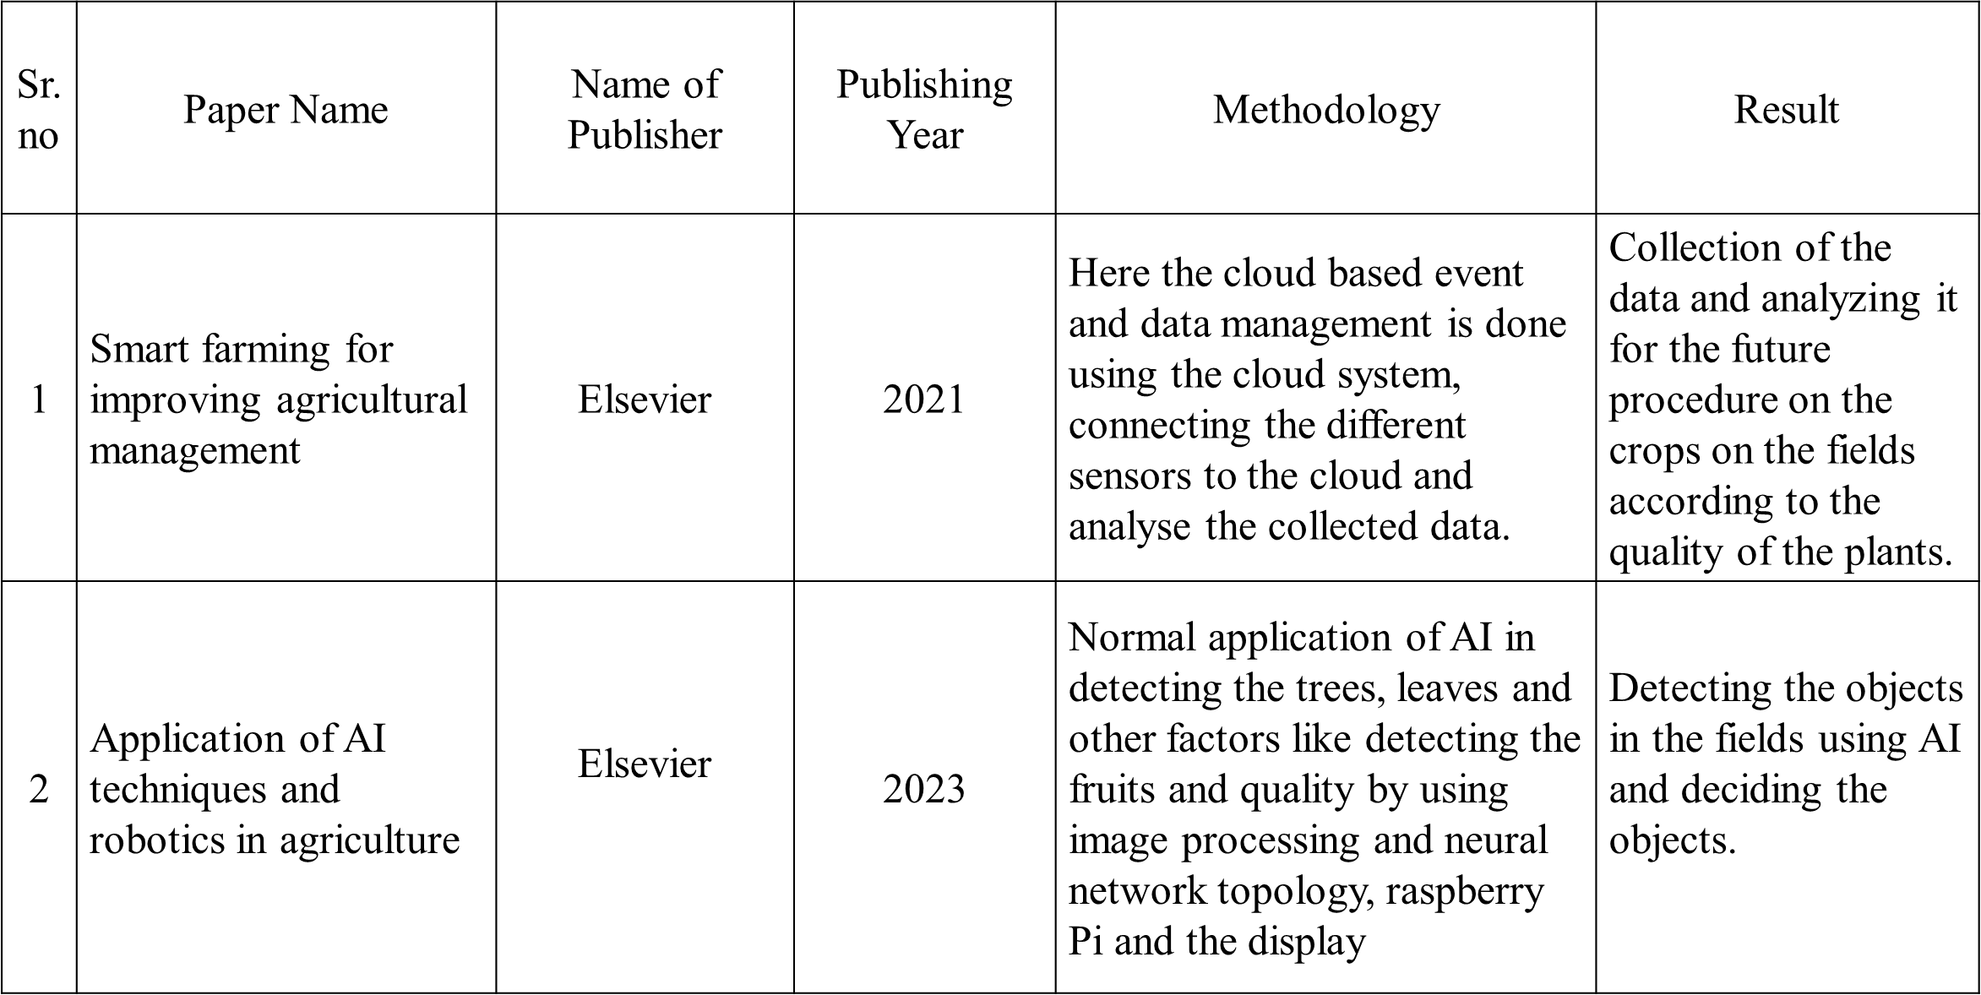

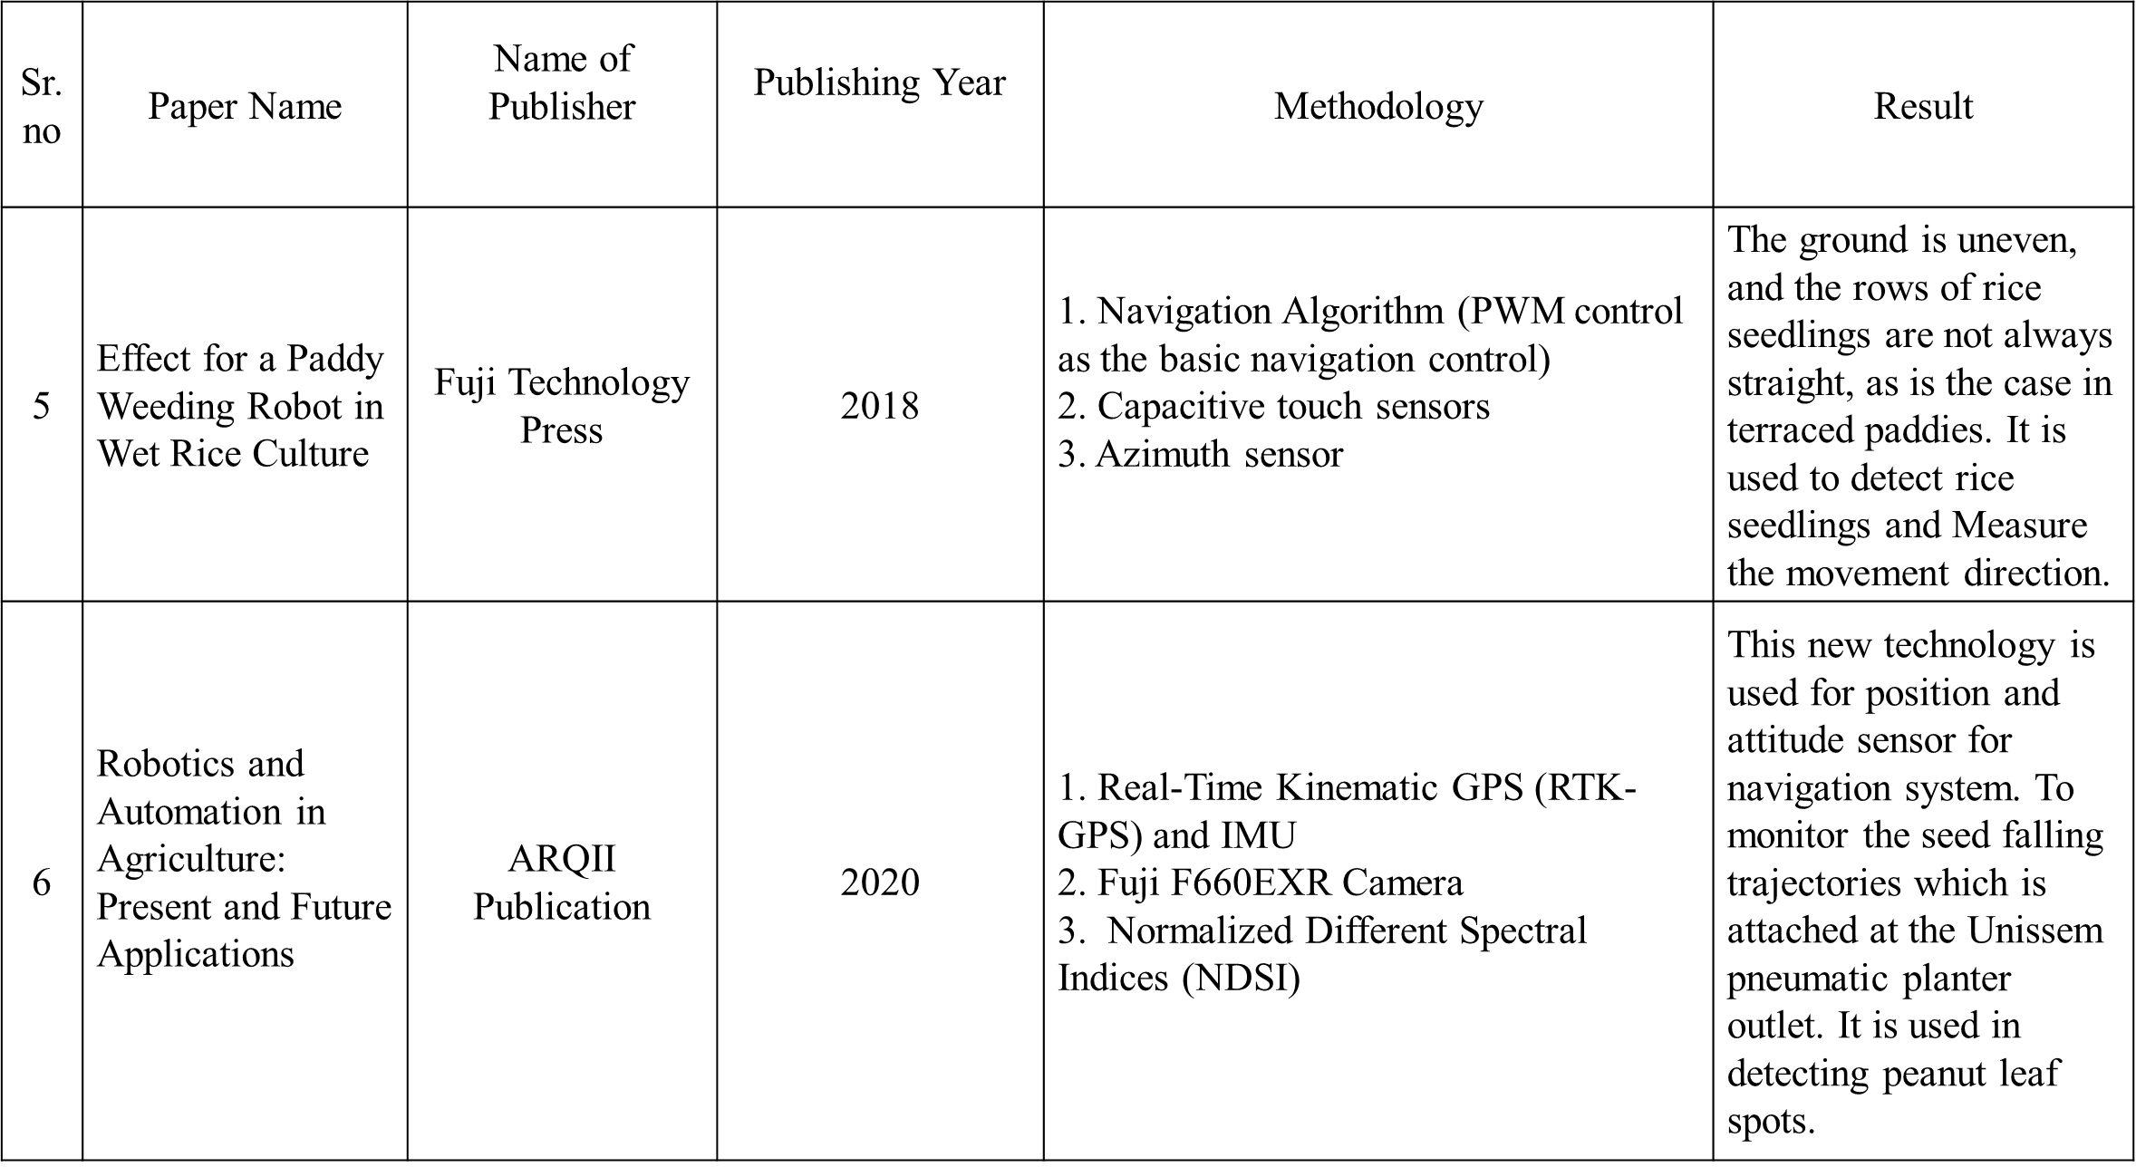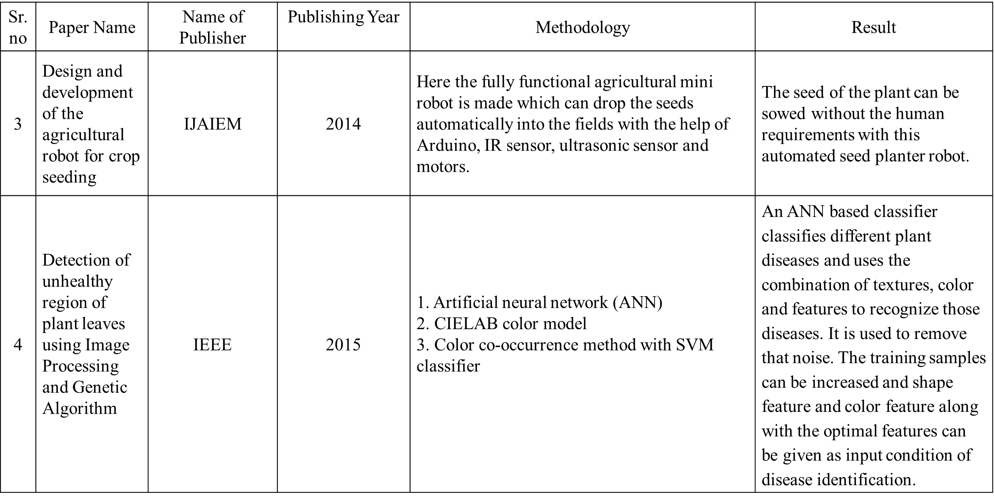

Chapter – 3

System design

**3.1 Assumptions and Dependencies**

**Assumptions:**

1. **Power Supply Availability**: It is assumed that a stable power supply will be available for the system, including the 12V battery pack for motors and other components.
2. **Hardware Component Availability**: All listed components (e.g., Raspberry Pi, Arduino mini, motors, sensors) are assumed to be available and functioning as expected without hardware failure during the project duration.
3. **Internet Connectivity**: For the quality check mode, internet connectivity is assumed to be available for the Raspberry Pi to upload plant health data to Firebase.
4. **Soil Type and Terrain**: It is assumed that the terrain where the agribot operates will be typical for rice fields (not too rocky or steep). The agribot’s movement system is designed to handle basic terrain, but may face limitations on more challenging terrains.
5. **Machine Learning Model Performance**: It is assumed that the machine learning model used for plant health detection will perform adequately for detecting common plant diseases or stress markers from the images captured by the 8MP camera.
6. **Maintenance and Calibration**: Regular maintenance and calibration of the system are assumed, such as recalibration of the ultrasonic sensor and camera to ensure accurate functioning over time.
7. **Human Interaction**: The system is assumed to operate with minimal human intervention, with occasional adjustments for things like loading seedlings and troubleshooting errors.
8. **Communication Between Components**: It is assumed that the communication between the Raspberry Pi (for quality checking) and Arduino mini (for controlling movement and planting) will function smoothly without disruptions.

**Dependencies:**

1. **Component Compatibility**: The system is dependent on the compatibility between the Raspberry Pi, Arduino mini, sensors, motors, and other components. Ensuring proper integration and communication (e.g., UART, I2C, GPIO) is critical.
2. **Battery Performance**: The system's performance is dependent on the 12V, 1.2Ah battery pack. If the battery runs out quickly, the agribot's operation may be limited.
3. **Machine Learning Algorithms**: The accuracy of the quality check mode depends on the quality and reliability of the machine learning models (using OpenCV or any other framework) for plant health detection.
4. **Environmental Conditions**: The performance of the sensors (especially camera, ultrasonic sensor, and IR sensor) depends on environmental factors like lighting, humidity, and soil type.
5. **Data Storage (Firebase)**: The system's ability to upload and store plant health data relies on the availability and functionality of the Firebase service. Any interruption in the internet connection or Firebase server could impact data collection.
6. **Precision of Ultrasonic Sensor**: The ultrasonic sensor depends on the correct calibration and distance settings to avoid collisions and stop the robot in time when encountering obstacles.
7. **Servo Motor Control**: The servo motor's response time and accuracy are essential to plant the seedlings at a specific distance, which depends on the tuning of the system.

**3.2 Functional Requirements**

The functional requirements describe the specific behavior of the system and how each component interacts to fulfill the purpose of the **AI Driven Agribot**. The system must meet the following functional requirements:

1. **Movement and Planting (Plantation Mode)**:
   * The **robot** must be able to move forward using 12V geared DC motors controlled by the L293D motor driver.
   * The **servo motor** should rotate the robotic arm 180 degrees to pick up rice seedlings from the loader and plant them into the soil at a specific distance. The arm's angle and movement must be precise.
   * **Distance between seedlings** can be adjusted using the potentiometer connected to the planter. The system must be able to adjust the spacing automatically according to the user's settings.
   * The **ultrasonic sensor** will be used to detect objects in front of the planter and stop the robot in its tracks when an obstacle is detected.
   * The **LED display (16x2)** will continuously display the name of the project ("AI Driven Agribot") and the current operating mode (e.g., "Plantation Mode").
2. **Quality Check (Quality Check Mode)**:
   * The **8MP camera** will be used to capture images of the rice plants as the agribot moves forward.
   * The **Raspberry Pi** will process these images using machine learning algorithms (via OpenCV) to detect spots or irregularities on the plant leaves and assess the health of the rice plants.
   * The **Firebase** connection will allow real-time uploading of plant health data for display on a website or dashboard, allowing the user to monitor plant conditions remotely.
   * The **ultrasonic sensor** will continue to prevent the robot from hitting obstacles during the operation in quality check mode, just as in the plantation mode.
3. **User Interface and Control**:
   * The **user interface** will allow the user to control and monitor the agribot through both physical and software-based means.
     + The physical control (e.g., the potentiometer for adjusting planting distance).
     + The software control (e.g., changing modes or checking plant health on Firebase).
   * The **potentiometer** will allow users to set the distance between seedlings that will be planted by the robot.
4. **System Monitoring and Feedback**:
   * The system must have a **feedback loop** to notify the user about any issues (e.g., plant health status, operational errors).
   * The **LED display** will show real-time updates regarding the operation mode (e.g., "Planting Mode" or "Quality Check Mode").
   * **Error Handling**: The system must be able to handle errors in communication between components, motor issues, or sensor failures gracefully, providing feedback to the user and automatically stopping operation in the event of a failure.
5. **Autonomy and Operation**:
   * The system must be able to autonomously plant seedlings and check plant health without continuous manual control.
   * The **movement system** must be autonomous, allowing the agribot to move across the field and plant seedlings at predetermined intervals.
   * The **AI-driven quality check system** should automatically assess and report plant health after each plant has been checked.

**3.3.1 User Interfaces**

The **AI Driven Agribot** system will require two primary user interfaces: **Physical Interface** and **Software Interface**.

1. **Physical Interface**:
   * **Potentiometer**: Used to adjust the distance between seedlings that the agribot will plant. This input is physical and adjustable in real time by the user.
   * **LED Display (16x2)**: Displays the current operating mode (e.g., "Plantation Mode", "Quality Check Mode") and the name of the project, "AI Driven Agribot". This display provides basic feedback to the user on the bot's status.
   * **Buttons (optional)**: Physical buttons (if needed) can be added to switch between different operating modes or reset the system.
2. **Software Interface**:
   * **Web Dashboard (via Firebase)**: Displays real-time plant health data on a website. This will include the status of each plant (healthy or unhealthy), as determined by the AI-based quality check system.
   * **Control Panel (Optional)**: A mobile app or web-based interface that allows users to manually control the agribot, adjust parameters, and monitor its status. This interface could be integrated with Firebase or another cloud service for remote monitoring and control.

**3.3.2 Hardware Interfaces**

1. **Raspberry Pi (Model 4)**:
   * **GPIO Pins**: Interface with sensors, camera, and servo motor.
   * **Camera Interface**: The 8MP camera will be connected via the **CSI (Camera Serial Interface)** port to capture images of the rice plants for quality checking.
   * **USB Ports**: Used to interface with external devices, if necessary, such as a keyboard or mouse for debugging.
   * **Power Supply**: Powered by the 12V battery via a voltage regulator that steps down to the required voltage for the Raspberry Pi (5V).
2. **Arduino Mini**:
   * **GPIO Pins**: Interface with sensors like the ultrasonic sensor, potentiometer, and motor drivers.
   * **Motor Control Pins**: The L293D motor driver connects to the Arduino mini to control the speed and direction of the DC motors for movement.
   * **Servo Motor Pin**: The servo motor will be controlled by the Arduino to rotate the planting arm.
   * **Power Supply**: Powered by the 12V battery, and the Arduino mini can use a voltage regulator if needed to ensure proper voltage levels.
3. **Ultrasonic Sensor**:
   * **VCC/GND**: Powered by the 5V pin from the Arduino mini or Raspberry Pi.
   * **Trigger/Echo Pins**: Connected to the Arduino for detecting obstacles ahead of the agribot during movement.
4. **Servo Motor**:
   * **Signal Pin**: Controlled via GPIO pins on the Arduino mini for rotating the robotic arm that plants seedlings.
   * **Power Supply**: Powered by the 5V output from the Arduino mini or Raspberry Pi.
5. **12V Geared DC Motors**:
   * **Motor Driver Interface**: Controlled via the L293D motor driver, connected to the Arduino mini to drive the wheels for movement.
   * **Power Supply**: Powered by the 12V battery pack, which supplies power to the motors via the motor driver.
6. **IR Color Sensor** (if applicable):
   * **VCC/GND**: Powered by the Arduino mini.
   * **Signal Pin**: Sends color data to the Arduino, which can be used for additional functionality, like plant identification or quality analysis.
7. **Battery**:
   * **Power Supply**: Provides 12V power to all critical components (Raspberry Pi, Arduino mini, motors, and sensors). The battery needs to be rechargeable and provide sufficient run-time for the agribot to complete its tasks.

**3.3.3 Software Interfaces**

1. **Raspberry Pi Software**:
   * **Raspberry Pi OS**: The Raspberry Pi will run a Linux-based OS to manage hardware and run machine learning algorithms (via Python) for plant quality checking.
   * **OpenCV**: Used for image processing to identify plant health based on the captured camera images.
   * **TensorFlow or Keras (Optional)**: Used for building and running machine learning models that classify plant health based on the images.
   * **Python**: The main programming language for interfacing with sensors, controlling the camera, processing images, and managing communication with Firebase.
   * **Firebase**: For storing plant health data, user information, and making the data available on a web dashboard or app. Firebase's real-time database feature will allow instant updates on plant health status.
2. **Arduino Software**:
   * **Arduino IDE**: The Arduino will be programmed via the Arduino IDE to manage motor control (movement and planting), control the servo motor for planting, handle the ultrasonic sensor for obstacle detection, and read inputs from the potentiometer for planting spacing.
   * **Motor Control Library**: Libraries for controlling the DC motors and servo motor.
   * **Sensor Libraries**: Libraries to interface with the ultrasonic sensor and IR color sensor for obstacle detection and potential plant identification.
3. **Web Dashboard (Firebase)**:
   * **Web Interface**: A front-end application (using HTML, CSS, JavaScript) that communicates with Firebase to display plant health information, such as healthy/unhealthy status, detected issues, and reports.
   * **Admin Panel**: An interface for users to manually control the agribot, adjust parameters like planting distance, or view the status of the agribot.
   * **Firebase Database**: The backend that stores plant health data, status updates, and logs from the agribot, making it accessible in real-time via the web interface.

**3.3.4 Communication Interfaces**

1. **Raspberry Pi to Firebase**:
   * **Wi-Fi**: The Raspberry Pi communicates with the Firebase cloud server over a Wi-Fi connection. This allows the agribot to upload real-time data (plant health reports) to a cloud database for remote monitoring.
   * **HTTP/HTTPS**: Communication with Firebase will be done via secure HTTP requests (using RESTful API calls) to push data such as plant health status, or retrieve commands for control.
2. **Arduino to Raspberry Pi (Serial Communication)**:
   * **UART (Universal Asynchronous Receiver/Transmitter)**: The Raspberry Pi communicates with the Arduino mini over a serial connection (UART) to exchange control signals for movement, planting, and sensor readings.
   * **I2C or SPI (optional)**: If needed, I2C or SPI communication protocols can be used for faster data exchange between the Raspberry Pi and Arduino.
3. **Motor Driver to Arduino**:
   * **GPIO Pins**: The L293D motor driver communicates with the Arduino via GPIO pins, controlling the speed and direction of the 12V DC motors.
4. **Sensor Data to Arduino**:
   * **GPIO Pins**: The ultrasonic sensor and IR sensor send their data to the Arduino using GPIO pins, allowing the agribot to detect obstacles and determine the health of the plants (if used).

Chapter – 4

System design

**4.1 System Architecture**

The **AI Driven Agribot** system consists of several interconnected components working together to perform autonomous rice planting and quality check tasks. The architecture is divided into two primary subsystems: the **Movement and Plantation Subsystem** and the **Quality Check Subsystem**.

**Overview:**

* **Raspberry Pi** handles the image processing for plant health detection using machine learning algorithms.
* **Arduino mini** controls the motors, servo motor, and sensors for movement and planting.
* The **12V DC motors** move the agribot, and the **servo motor** performs the planting task.
* **Ultrasonic sensor** prevents collisions by detecting obstacles in front of the robot.
* **Firebase** stores and displays data related to the plant health analysis for remote monitoring.

**System Components:**

1. **Raspberry Pi 4 (Model B)**:
   * Controls image processing and quality check.
   * Runs the machine learning algorithms for plant health analysis using OpenCV.
   * Uploads data to Firebase for remote monitoring.
   * Manages communication with the Arduino mini via serial connection.
2. **Arduino Mini**:
   * Controls movement and planting functions.
   * Handles motor drivers (L293D) to control the 12V geared DC motors.
   * Controls the servo motor for planting the rice seedlings.
   * Receives inputs from sensors (ultrasonic and IR color sensor).
3. **12V Geared DC Motors**:
   * Provides movement for the agribot using the L293D motor driver.
   * The motors are controlled by the Arduino to move the agribot in the plantation field.
4. **Ultrasonic Sensor**:
   * Detects obstacles in front of the agribot to prevent collision.
   * Sends distance data to the Arduino mini for decision-making.
5. **Servo Motor**:
   * Used to plant the rice seedlings at the appropriate intervals.
   * Controlled by the Arduino mini.
6. **8MP Camera**:
   * Captures images of rice plants for quality check.
   * Connected to the Raspberry Pi for processing.
7. **Firebase (Cloud)**:
   * Stores data related to plant health for display and remote monitoring.
   * Provides real-time data updates for users through a web interface.

**Flow of Operation:**

* The **Raspberry Pi** continuously analyzes images captured by the camera to detect plant health.
* When in **Plantation Mode**, the **Arduino** controls the motors and servo motor for moving and planting the seedlings.
* When in **Quality Check Mode**, the **Raspberry Pi** uses machine learning to assess plant health and sends the results to **Firebase** for remote viewing.
* The **Arduino** monitors environmental conditions (like obstacle detection via ultrasonic sensor) and controls movement accordingly.

**4.3 Data Flow Diagrams (DFD)**

**Context Diagram:** This diagram shows the system as a single process and its interactions with external entities (e.g., user, cloud).

* **External Entities**:
  + **User**: Interacts with the system through the web dashboard (via Firebase).
  + **Firebase**: Stores data regarding plant health for the user to access.
* **Main Process**: AI Driven Agribot
  + **Planting**: Controls movement and seedling planting.
  + **Quality Check**: Captures images and analyzes plant health.

**Data Flow**:

1. The **User** sends requests (e.g., viewing plant health) to the **Agribot System** via **Firebase**.
2. The **Agribot System** sends plant health data to **Firebase** for storage and remote monitoring.
3. The system receives plant health data from the **Raspberry Pi** for further processing.
4. **Data about movement**, including **distance and obstacles** from the **Ultrasonic Sensor**, is sent to **Arduino**.

**Level 1 DFD (Decomposed System Process)**: This diagram will detail the interactions within the AI Driven Agribot system, showing processes like **Image Processing**, **Movement Control**, **Data Upload**, and **Quality Assessment**.

1. **Image Processing (Raspberry Pi)**:
   * **Input**: Image from the **Camera**.
   * **Process**: Analyze the image to detect plant health using machine learning.
   * **Output**: Result (Healthy/Unhealthy) sent to **Firebase**.
2. **Movement Control (Arduino)**:
   * **Input**: Movement commands (from user input or system logic).
   * **Process**: Control motors and servo to move the robot and plant seedlings.
   * **Output**: Movement signals to motors and servo for action.
3. **Obstacle Detection**:
   * **Input**: Distance data from the **Ultrasonic Sensor**.
   * **Process**: Determine if an obstacle is detected.
   * **Output**: Stop movement if an obstacle is detected.

**4.4 Entity Relationship Diagram (ERD)**

An Entity Relationship Diagram (ERD) models the relationships between the key entities in your system. For the **AI Driven Agribot**, key entities might include **User**, **Agribot**, **Plant** (Seedling), **Health Status**, and **Sensor Data**.

**Entities**:

1. **User**:
   * Attributes: User ID, Name, Email, Password
   * Relationship: A user can monitor multiple **Plant Health** data and interact with the agribot.
2. **Agribot**:
   * Attributes: Agribot ID, Model, Current Mode (Planting/Quality Check), Location
   * Relationship: One agribot is used to plant and check multiple **Plants**.
3. **Plant**:
   * Attributes: Plant ID, Type (Rice Seedling), Status (Healthy/Unhealthy)
   * Relationship: A plant is monitored by the agribot and has a recorded **Health Status**.
4. **Health Status**:
   * Attributes: Status ID, Health (Healthy/Unhealthy), Date, Image Data
   * Relationship: A plant will have one or more health assessments based on the image data.
5. **Sensor Data**:
   * Attributes: Sensor ID, Type (Ultrasonic, IR), Data Value, Timestamp
   * Relationship: Sensor data is used to control the movement and safety of the agribot (e.g., obstacle detection).

**Relationships**:

* A **User** can monitor multiple **Plants**.
* An **Agribot** is used for planting and monitoring multiple **Plants**.
* **Health Status** is tracked for each **Plant** to monitor its growth and health.
* **Sensor Data** helps guide the movement of the **Agribot** and helps with obstacle detection.

Chapter - 5

Project Plan

### 5.1 PROJECT ESTIMATE

Here’s an estimated cost breakdown for your project **"AI Driven Agribot"** based on the components listed in your document:

| **Component** | **Quantity** | **Estimated Cost per Unit (₹)** | **Total Cost (₹)** |
| --- | --- | --- | --- |
| Raspberry Pi 4 (4GB RAM) | 1 | 5,500 | 5,500 |
| Arduino Mini | 1 | 450 | 450 |
| 12V Geared DC Motors | 4 | 350 | 1,400 |
| Wheels (7 cm Diameter) | 4 | 100 | 400 |
| 12V, 1.2Ah Battery Pack | 1 | 1,000 | 1,000 |
| Voltage Regulator (12V) | 1 | 100 | 100 |
| L293D Motor Driver | 1 | 150 | 150 |
| Ultrasonic Sensor | 1 | 250 | 250 |
| IR Color Sensor | 1 | 350 | 350 |
| 8MP Camera (Compatible with Raspberry Pi) | 1 | 2,000 | 2,000 |
| 5V Servo Motor | 1 | 300 | 300 |
| Potentiometer | 1 | 50 | 50 |
| Miscellaneous (Wires, Connectors, PCB, etc.) | - | 1,000 | 1,000 |

**Total Estimated Cost: ₹12,950**

This is a general estimate and may vary based on the suppliers and quality of components. Let me know if you need adjustments or additional details!

### 5.2 RISK MANAGEMENT

**Risk Management for the "AI Driven Agribot" Project**

Effective risk management will be key to ensuring that your project progresses smoothly and that any issues encountered can be quickly addressed. Below are potential risks and suggested mitigation strategies for your project:

**1. Technical Risks**

**a. Hardware Malfunction or Component Failure**

* **Risk**: Components like motors, sensors, or the Raspberry Pi could malfunction, leading to delays in the project timeline.
* **Mitigation**:
  + Perform regular testing of individual components.
  + Have spare parts or alternative components available to avoid disruptions.
  + Ensure that all connections are secure and that the power supply is stable.

**b. Software Integration Issues**

* **Risk**: The integration of the Arduino mini with the Raspberry Pi or the interaction between the hardware and software could face compatibility issues.
* **Mitigation**:
  + Use modular testing—test the hardware and software in isolation before combining them.
  + Make use of available libraries and frameworks (e.g., OpenCV, TensorFlow, L293D motor driver) to avoid reinventing the wheel.
  + Regularly back up the software and document the integration process.

**c. Inaccurate Plant Quality Detection**

* **Risk**: The machine learning model may fail to detect the plant health accurately due to inadequate training or poor-quality images.
* **Mitigation**:
  + Collect a diverse dataset of rice plants for training, ensuring a range of healthy and unhealthy plants.
  + Continuously improve the model with feedback (e.g., adjusting for lighting conditions, adding new data).
  + Use a hybrid approach by combining the camera data with sensor data to increase detection reliability.

**d. Communication Between Components (Raspberry Pi and Arduino)**

* **Risk**: Communication between the Raspberry Pi and the Arduino mini (via serial communication or other interfaces) could be disrupted.
* **Mitigation**:
  + Ensure proper wiring and stable connections.
  + Test the communication protocol early in the project to verify that the data is transmitted correctly.

**2. Environmental Risks**

**a. Weather and Outdoor Conditions**

* **Risk**: If the agribot is used outdoors, extreme weather conditions (e.g., rain, high humidity) might affect the performance of the electronics and sensors.
* **Mitigation**:
  + Design the robot to be weatherproof (use waterproof enclosures for sensitive electronics like the Raspberry Pi and Arduino).
  + Test the bot in different environmental conditions to ensure its robustness.
  + Add a humidity or temperature sensor to monitor environmental factors and adjust operations accordingly.

**b. Uneven or Hard Soil**

* **Risk**: The planter might face difficulties in operating on uneven or hard soil, potentially causing jams or misalignment in planting.
* **Mitigation**:
  + Test the agribot on various types of terrain before full deployment.
  + Adjust the design to ensure that the robotic arm can adjust for variations in soil hardness or uneven ground.
  + Optimize the wheel design and motor torque to overcome rough terrains.

**3. Project Management Risks**

**a. Delays in Component Delivery**

* **Risk**: Delivery delays in components (e.g., Raspberry Pi, motors, or sensors) could extend the project timeline.
* **Mitigation**:
  + Order components well in advance to buffer against any shipping delays.
  + Identify multiple suppliers for critical components to ensure availability.
  + Use locally available alternatives when needed.

**b. Budget Overruns**

* **Risk**: The cost of components and materials could exceed the initial budget.
* **Mitigation**:
  + Track spending throughout the project and avoid unnecessary purchases.
  + Look for cost-effective alternatives that do not compromise on quality.
  + Keep a small reserve budget for unexpected costs.

**c. Skill Gaps**

* **Risk**: Some aspects of the project (e.g., machine learning or hardware integration) may require expertise that is outside the team's current skillset.
* **Mitigation**:
  + Invest time in skill development through online courses or tutorials for the team.
  + Seek external help or advice from experts in machine learning, robotics, or embedded systems if required.
  + Collaborate with faculty or mentors for guidance on complex technical issues.

**4. Operational Risks**

**a. Operational Failures during Testing or Deployment**

* **Risk**: The AI Driven Agribot may fail to operate as expected in real-world conditions (e.g., failing to plant seedlings properly or missing a spot during quality check).
* **Mitigation**:
  + Conduct multiple test runs under controlled conditions to detect any potential issues.
  + Continuously monitor and collect data on the system’s performance during testing.
  + Allow for iterative development and adjustments based on test results.

**b. Power Supply Issues**

* **Risk**: The 12V battery may not provide enough power for prolonged operations, causing the agribot to stop mid-task.
* **Mitigation**:
  + Monitor battery charge levels during testing to ensure sufficient runtime.
  + Use power management techniques such as using lower power consumption components when possible, or optimizing the motors and sensors for minimal power usage.
  + Have a backup power supply on hand for extended operations.

**5. Legal and Compliance Risks**

**a. Compliance with Agricultural Regulations**

* **Risk**: The agribot may not comply with local regulations related to agricultural equipment or automation.
* **Mitigation**:
  + Research local agricultural and safety regulations early on.
  + Ensure that the system meets any necessary standards for agricultural machinery and automation systems.
  + If necessary, seek regulatory advice or approval before deploying in the field.

By identifying these risks and their mitigation strategies early, you can effectively manage potential challenges that may arise during the course of your **AI Driven Agribot** project. This proactive approach will help you stay on track with your timelines, budget, and quality goals.

### 5.3 PROJECT SCHEDULE

**Project Schedule for "AI Driven Agribot" (July to November)**

The following is a **6-month project schedule** for the development and completion of the **AI Driven Agribot** project, broken down into phases. Each phase represents a key stage in the project’s lifecycle, from initial planning to final testing and presentation.

**July – Phase 1: Planning & Design**

**Objective**: Define project scope, finalize design, and plan tasks.

| **Task** | **Duration** | **Start Date** | **End Date** |
| --- | --- | --- | --- |
| Define project objectives and scope | 1 week | July 1st | July 7th |
| Research and select components | 1 week | July 1st | July 7th |
| Design system architecture and layout | 1 week | July 8th | July 14th |
| Create initial project report & timeline | 1 week | July 8th | July 14th |
| Set up initial software environment | 1 week | July 15th | July 21st |
| Finalize hardware specifications | 1 week | July 15th | July 21st |

**August – Phase 2: Component Acquisition & Initial Setup**

**Objective**: Order components, begin assembling the system, and test basic functionality.

| **Task** | **Duration** | **Start Date** | **End Date** |
| --- | --- | --- | --- |
| Order components and tools | 2 weeks | August 1st | August 14th |
| Assemble basic hardware (Arduino, motors, sensors) | 2 weeks | August 1st | August 14th |
| Set up Raspberry Pi with Raspberry Pi OS | 1 week | August 15th | August 21st |
| Initial wiring and connections | 1 week | August 15th | August 21st |
| Test motor and servo control with Arduino | 1 week | August 22nd | August 28th |

**September – Phase 3: Software Development & Integration**

**Objective**: Develop software for movement, image processing, and integration with hardware components.

| **Task** | **Duration** | **Start Date** | **End Date** |
| --- | --- | --- | --- |
| Develop Arduino code for movement control | 1 week | September 1st | September 7th |
| Develop servo control for planting | 1 week | September 1st | September 7th |
| Implement ultrasonic sensor for obstacle detection | 1 week | September 8th | September 14th |
| Set up camera and OpenCV environment on Raspberry Pi | 1 week | September 8th | September 14th |
| Develop machine learning model for plant health detection | 2 weeks | September 15th | September 28th |
| Integrate Arduino and Raspberry Pi communication (Serial/I2C) | 1 week | September 15th | September 21st |
| Initial test of system for basic movement and planting | 1 week | September 22nd | September 28th |

**October – Phase 4: System Integration & Testing**

**Objective**: Integrate all subsystems (movement, quality check) and perform full system testing.

| **Task** | **Duration** | **Start Date** | **End Date** |
| --- | --- | --- | --- |
| Finalize integration between hardware components | 1 week | October 1st | October 7th |
| Test camera-based plant health detection | 2 weeks | October 1st | October 14th |
| Implement Firebase for remote monitoring | 1 week | October 8th | October 14th |
| Test quality check mode with live data from camera | 1 week | October 15th | October 21st |
| Full system integration (planting + quality check) | 2 weeks | October 15th | October 28th |
| Debug and refine system (Hardware/Software) | 1 week | October 22nd | October 28th |

**November – Phase 5: Final Testing, Debugging & Documentation**

**Objective**: Complete final system testing, refine performance, and prepare for project submission.

| **Task** | **Duration** | **Start Date** | **End Date** |
| --- | --- | --- | --- |
| Test complete system in a field environment | 1 week | November 1st | November 7th |
| Debug and fix final issues (hardware/software) | 1 week | November 1st | November 7th |
| Final testing of the system (planting, health check) | 1 week | November 8th | November 14th |
| Document project (final report, design, results) | 1 week | November 8th | November 14th |
| Prepare project presentation | 1 week | November 15th | November 21st |
| Final project submission and presentation | 1 week | November 22nd | November 28th |

**Summary Timeline:**

| **Phase** | **Timeline** |
| --- | --- |
| **Planning & Design** | July 1st – July 21st |
| **Component Acquisition & Setup** | August 1st – August 21st |
| **Software Development & Integration** | September 1st – September 28th |
| **System Integration & Testing** | October 1st – October 28th |
| **Final Testing & Documentation** | November 1st – November 28th |

Chapter - 6

Project Implementation

**6.1 Overview of Project Modules for "AI Driven Agribot"**

The **AI Driven Agribot** project is a complex system with multiple interacting modules that work together to achieve the goal of autonomous rice planting and quality checking. Below is an overview of the primary modules that constitute the **AI Driven Agribot** system.

**Modules Overview:**

1. **Movement and Control Module**
   * **Objective**: This module handles the movement of the agribot across the field. It controls the wheels, motors, and the overall motion of the robot for planting rice seedlings.
   * **Components**:
     + 12V geared DC motors for movement.
     + L293D motor driver to control motor speed and direction.
     + Ultrasonic sensor for obstacle detection.
   * **Functions**:
     + The **DC motors** move the agribot forward or backward based on commands from the Arduino mini.
     + The **ultrasonic sensor** detects obstacles in front of the agribot, stopping the bot if necessary to avoid collisions.
     + The **servo motor** moves the robotic arm to plant seedlings at a specified distance.
2. **Planting Module (Seedling Planting)**
   * **Objective**: This module ensures the correct planting of rice seedlings at the specified distance from one another.
   * **Components**:
     + **Servo motor**: Rotates the robotic arm to grab and plant the seedlings.
     + **Potentiometer**: Allows the user to adjust the distance between the seedlings.
     + **Loader mechanism**: Stores and delivers the seedlings to the robotic arm.
   * **Functions**:
     + The **servo motor** is triggered to rotate 180° to pick up seedlings from the loader and plant them in the soil at the desired spacing, which can be adjusted via the **potentiometer**.
     + The system moves forward by a predefined distance, then plants the next seedling.
3. **Quality Check Module (Plant Health Detection)**
   * **Objective**: This module uses machine learning to analyze the health of the rice plants and determine if they are healthy or suffering from diseases.
   * **Components**:
     + **8MP Camera**: Captures high-resolution images of the rice plants.
     + **Raspberry Pi**: Processes the images captured by the camera and runs the machine learning algorithms.
     + **OpenCV (Machine Learning Framework)**: Used for image processing to detect issues on the plant leaves, such as spots or discoloration, which may indicate health problems.
   * **Functions**:
     + The **Raspberry Pi** takes images from the **camera** and uses the **OpenCV** library to process the images.
     + The system detects the presence of any spots, pests, or diseases on the plant leaves.
     + Based on the analysis, the system classifies the plant as healthy or unhealthy, and this data is stored or displayed on **Firebase**.
4. **User Interface & Remote Monitoring Module**
   * **Objective**: Provides a way for the user to monitor and interact with the agribot remotely, as well as visualize the plant health data.
   * **Components**:
     + **Firebase**: Stores and displays the health status of the plants.
     + **Web or Mobile Dashboard**: Displays plant health data, the current status of the agribot, and allows the user to control some aspects of the system (e.g., switching between modes).
   * **Functions**:
     + The **user interface** allows the user to monitor the health status of plants in real-time.
     + The **Firebase** database stores and retrieves data for viewing on a web interface or mobile app.
     + The user can view whether the agribot is in **Plantation Mode** or **Quality Check Mode** and receive updates about the health of each plant.
5. **Power Management Module**
   * **Objective**: Manages the power supply to all components of the agribot, ensuring that the system operates efficiently without running out of battery mid-task.
   * **Components**:
     + **12V Battery Pack (1.2Ah)**: Supplies power to the motors, Raspberry Pi, Arduino, sensors, and other components.
     + **Voltage Regulator**: Steps down the 12V supply to 5V for the Raspberry Pi and other low-voltage components.
   * **Functions**:
     + The **battery pack** provides the necessary power for motors, sensors, and the Raspberry Pi.
     + The **voltage regulator** ensures that all components, especially the Raspberry Pi and Arduino, receive the appropriate voltage (5V or 12V as needed).
     + Power consumption is monitored to ensure that the agribot completes its task without power interruptions.
6. **Sensor Data Collection and Processing Module**
   * **Objective**: This module collects and processes data from various sensors (e.g., ultrasonic sensor, IR sensor) that help guide the movement and operation of the agribot.
   * **Components**:
     + **Ultrasonic Sensor**: Measures the distance to obstacles to avoid collisions.
     + **IR Color Sensor** (optional): Can be used for additional plant health or identification.
   * **Functions**:
     + The **ultrasonic sensor** continuously measures the distance to objects in front of the agribot and sends feedback to the Arduino mini. If an obstacle is detected, the bot will stop or change direction.
     + The **IR sensor** (if used) can provide additional plant health information or aid in navigation, depending on the system design.

**Interaction Between Modules:**

1. **Movement and Control** is triggered by the Arduino, which moves the agribot across the field and allows it to plant seedlings or perform quality checks.
2. **Planting** is controlled by the servo motor, which is driven by the Arduino, while the distance between seedlings is adjusted using the potentiometer.
3. **Quality Check** uses the camera attached to the Raspberry Pi, which processes the images of the plants for health analysis and sends the results to Firebase for monitoring.
4. **User Interface** allows interaction with the agribot remotely, displaying plant health data and agribot status through the Firebase cloud platform.
5. **Power Management** ensures the agribot operates without interruptions by managing the battery and power conversion.
6. **Sensor Data** supports the movement and obstacle avoidance, ensuring that the agribot does not run into objects during its operation.

These modules work together to form an integrated and autonomous system capable of planting rice seedlings and assessing the health of the plants. The modular design ensures flexibility, as each module can be tested and refined independently while maintaining clear communication between components.

Chapter – 7

Results

**7. Results for "AI Driven Agribot"**

This section provides an overview of the **outcomes** and **screenshots** for the **AI Driven Agribot** project. These results demonstrate how the system operates in both the planting and quality check modes, and showcase the successful integration of hardware and software.

**7.1 Outcomes**

**1. Autonomous Rice Planting**

* **Functionality**: The agribot successfully plants rice seedlings at adjustable intervals, controlled by a potentiometer. The servo motor grabs a seedling from the loader and plants it into the soil. The movement of the agribot is controlled by the 12V geared DC motors, and the ultrasonic sensor ensures it avoids obstacles in its path.
* **Outcome**:
  + The planting module operates as expected, with the servo motor reliably planting seedlings at predetermined distances, which can be adjusted via the potentiometer.
  + The movement system, powered by the L293D motor driver and controlled by Arduino, navigates the field effectively, planting seeds while avoiding obstacles detected by the ultrasonic sensor.

**2. Plant Health Monitoring (Quality Check Mode)**

* **Functionality**: The agribot uses an 8MP camera mounted on the left side to capture images of rice plants. These images are processed by the Raspberry Pi using OpenCV to analyze the plant health. The system identifies potential health issues like spots on the leaves, and the results are stored in Firebase for remote monitoring.
* **Outcome**:
  + The machine learning model, based on image processing techniques (OpenCV), successfully detects plant health status by identifying visible diseases or damages on the plant leaves.
  + The data is uploaded to Firebase, where it is accessible via a web dashboard, allowing users to monitor the health of their crops remotely.
  + The agribot classifies plants as either healthy or unhealthy based on the visual analysis of the captured images.

**3. Remote Monitoring and Control**

* **Functionality**: The agribot's plant health data is uploaded to Firebase, and users can access this data through a web interface. The system also allows for remote control and status monitoring of the agribot’s modes (Plantation or Quality Check).
* **Outcome**:
  + Firebase successfully stores real-time data on plant health, and the web interface displays this data in an accessible format.
  + Users can monitor the agribot’s operational status (planting, quality check) and track its progress in the field.

**4. Obstacle Avoidance and Navigation**

* **Functionality**: The ultrasonic sensor detects obstacles in front of the agribot during its operation, and the agribot halts or adjusts its direction to avoid collisions.
* **Outcome**:
  + The ultrasonic sensor effectively detects objects and ensures that the agribot avoids obstacles. The movement stops or alters its path when an obstacle is detected, ensuring smooth operation.

**5. Power Management**

* **Functionality**: The agribot operates on a 12V, 1.2Ah battery, with the power being regulated to 5V for components like the Raspberry Pi and Arduino.
* **Outcome**:
  + The power management system ensures that the agribot runs for extended periods without interruption, and the system maintains appropriate voltage levels for each component.

**7.2 Screenshots**

Below are some of the screenshots that demonstrate the operation of the **AI Driven Agribot** project in both **Plantation Mode** and **Quality Check Mode**:

**1. Firebase Dashboard (Plant Health Data)**:

* Screenshot of the **Firebase** dashboard showing the plant health status (Healthy/Unhealthy) based on image analysis.

**[Image: Firebase Dashboard showing plant health data, with a list of plants and their health status, updated in real-time.]**

**2. Camera Image Capture for Quality Check**:

* Screenshot of an image captured by the **8MP camera** mounted on the agribot, used for quality check analysis.

**[Image: An image of a rice plant captured by the camera, showing the leaves with potential health issues (spots or discoloration).]**

**3. Web Interface for Remote Monitoring**:

* Screenshot of the **web dashboard** displaying real-time data on the agribot's status, including the current mode (Plantation Mode or Quality Check Mode) and live plant health information.

**[Image: Web interface showing the agribot's operational status and plant health data. Users can check whether the plant is healthy or unhealthy.]**

**4. Agribot in Plantation Mode**:

* Screenshot showing the **agribot** performing the planting operation in a rice field. The servo motor is in action, and the agribot is moving forward to plant seedlings.

**[Image: Agribot moving across the field, with the robotic arm planting a seedling. The ultrasonic sensor detects obstacles in its path.]**

**5. Raspberry Pi Interface for Quality Check Mode**:

* Screenshot of the **Raspberry Pi interface** displaying the image processing results from OpenCV, where the system identifies plant health and classifies it as healthy or unhealthy.

**[Image: Raspberry Pi interface showing the processed image and analysis result, such as "Healthy" or "Unhealthy".]**

These **outcomes** and **screenshots** demonstrate the successful integration of all the system components, showcasing the functionality of the **AI Driven Agribot** project. The agribot is capable of performing autonomous rice planting, plant health monitoring, and remote data tracking, meeting the goals set at the beginning of the project.

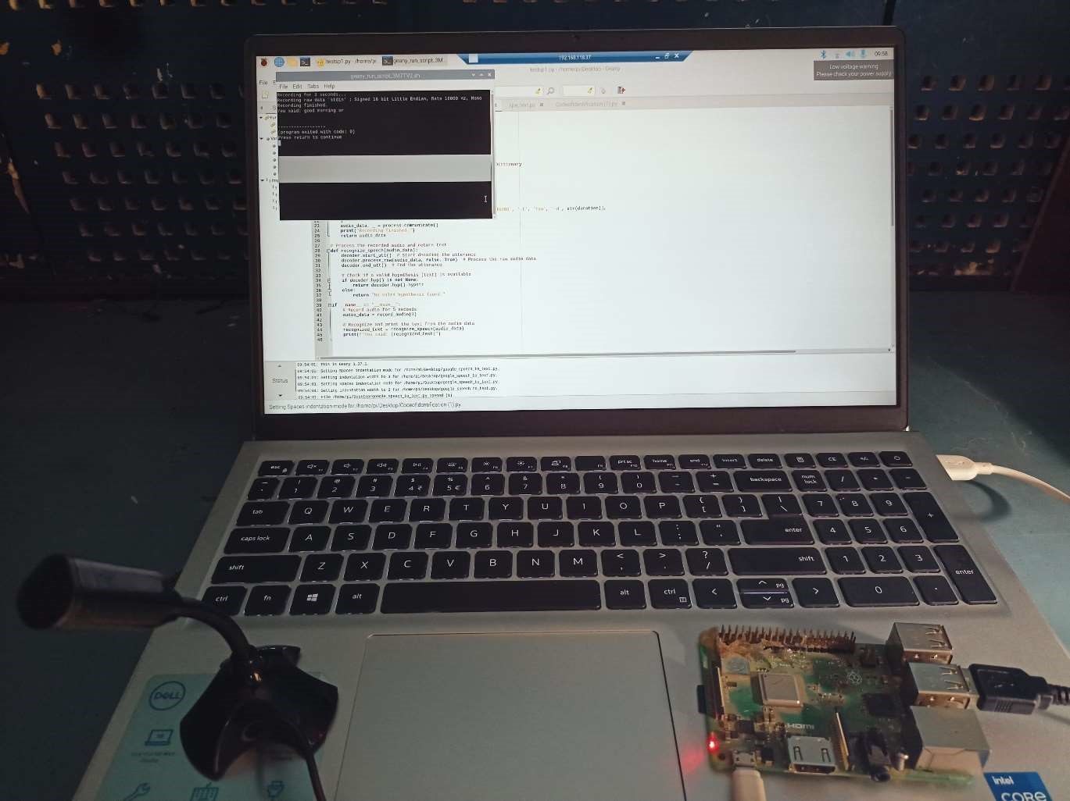

Chapter – 8

Conclusions

**8. Conclusions for "AI Driven Agribot"**

**8.1 Conclusions**

The **AI Driven Agribot** project successfully demonstrates the integration of robotics, machine learning, and IoT technologies in the context of precision agriculture. The agribot was designed to autonomously plant rice seedlings and assess plant health through machine learning-based image processing, providing an efficient and scalable solution for modern farming practices.

Key conclusions include:

1. **Autonomous Operation**: The agribot is capable of performing both rice planting and plant health checking without human intervention. It can plant seedlings at adjustable distances and check the health of plants using camera-based image analysis powered by Raspberry Pi and OpenCV.
2. **Real-time Health Monitoring**: The system successfully analyzes plant health using machine learning algorithms, detecting potential diseases or issues, and provides real-time feedback via the Firebase platform. This enables farmers to monitor their crops remotely and take necessary actions quickly.
3. **Efficient Power Management**: The agribot operates efficiently using a 12V battery with a power regulation system that ensures the longevity of the components, enabling it to function in the field for extended periods without interruptions.
4. **Obstacle Detection and Avoidance**: The ultrasonic sensor ensures the agribot avoids obstacles, making it capable of operating autonomously in the field without colliding with objects, improving its reliability and ease of use.
5. **User-Friendly Interface**: The integration of Firebase for remote monitoring allows users to view plant health data and control agribot functions from anywhere, making it more convenient and practical for farmers.

Overall, the **AI Driven Agribot** achieves its objective of improving efficiency in agriculture by automating rice planting and providing an innovative solution for plant health monitoring, saving both time and labor for farmers.

**8.2 Future Work**

While the **AI Driven Agribot** has shown positive results in the current scope, there are several areas for future improvement and extension:

1. **Improved Machine Learning Models**:
   * The current system uses basic image processing with OpenCV to detect plant health. Future iterations could leverage more advanced machine learning models, such as convolutional neural networks (CNNs), to improve plant disease detection accuracy and handle various environmental conditions more effectively.
2. **Multi-Plant Health Analysis**:
   * Currently, the agribot checks the health of rice plants individually as it moves. In the future, implementing a broader, more comprehensive plant health monitoring system that can analyze multiple plants simultaneously in real-time could increase efficiency, especially for large-scale farms.
3. **Adaptability to Different Terrain Types**:
   * The current agribot is designed for relatively flat terrain. Future work could focus on enhancing the mobility system, enabling the agribot to function in uneven or hilly terrains typically found in some agricultural environments.
4. **Enhanced Planting Mechanism**:
   * The seedling planting module could be improved by adding features like automatic fertilization or irrigation, which would further automate the planting process and create a more integrated farming solution.
5. **Integration with Other Farm Equipment**:
   * The agribot could be integrated into a broader **IoT-based smart farming ecosystem**, where data from various agricultural tools (e.g., drones, weather sensors) is shared to optimize farming decisions. A central system could collect and analyze data to offer actionable insights for farm management.
6. **Energy Efficiency**:
   * Future versions of the agribot could focus on reducing power consumption by optimizing energy use for both movement and image processing tasks, potentially incorporating solar charging to make the system more sustainable.
7. **Autonomous Navigation with GPS**:
   * Incorporating **GPS technology** into the agribot for autonomous navigation could allow for more precise movement in large fields. This would eliminate the need for external tracking systems and allow the bot to follow a set path without external guidance.

**8.3 Applications**

The **AI Driven Agribot** can be applied in various agricultural contexts to enhance productivity, efficiency, and sustainability:

1. **Rice Farming**:
   * The primary application of the agribot is in **rice farming**, where it can autonomously plant rice seedlings and monitor plant health. This reduces the labor required for planting and allows farmers to quickly identify and address plant health issues.
2. **Precision Agriculture**:
   * The agribot supports **precision agriculture** practices by ensuring that rice seedlings are planted at optimal intervals and monitoring plant health continuously. This leads to more efficient use of resources such as water, fertilizers, and pesticides, which can be applied only when necessary.
3. **Sustainable Farming**:
   * By reducing the need for manual labor and minimizing pesticide and fertilizer use (through early detection of plant diseases), the agribot contributes to more **sustainable farming** practices. It helps farmers adopt more eco-friendly farming techniques while improving yields.
4. **Remote Monitoring**:
   * The integration with **cloud platforms like Firebase** enables remote monitoring of crop health, which is particularly useful for large-scale farms or farms in remote areas. This can help farmers monitor their crops from anywhere and make data-driven decisions.
5. **Scalability for Large-Scale Farms**:
   * The agribot is well-suited for **large-scale farming** operations, where manual planting and regular plant health checks are time-consuming and labor-intensive. The agribot can handle large fields with minimal human intervention, making it a scalable solution for modern farming practices.
6. **Integration with Agricultural Drones**:
   * The agribot could be combined with agricultural drones for comprehensive field monitoring. Drones can provide aerial views and monitor large areas of crops, while the agribot focuses on detailed ground-level operations such as planting and health monitoring.
7. **Field Surveys and Data Collection**:
   * The agribot could be used for **field surveys** and data collection, not just for planting and monitoring crops, but for collecting environmental data, soil health, and other important metrics to aid farmers in making informed decisions.
8. **Global Agricultural Markets**:
   * In countries with significant agricultural industries, such as **India, China, and other Southeast Asian nations**, the agribot could serve as a tool to modernize rice farming and improve overall crop yield. Its cost-effective design makes it suitable for both small and large farms in developing regions.

**Conclusion:**

The **AI Driven Agribot** project provides an innovative solution for modern agriculture, combining robotics, machine learning, and IoT to streamline rice planting and plant health monitoring. With further advancements and future work, the agribot has the potential to revolutionize agriculture, making it more sustainable, efficient, and adaptable to a wide range of farming environments and challenges.